ITSIMPLERA FULLSTACK WEB DEVELOPMENT INTERNSHIP
TaskForge
Authentication & Task Management Platform
Week 1 Task — Project Documentation
SUBMITTED by TAZNEELA IBRAHIM
Stack: MongoDB · Express.js · React.js · Node.js (MERN)
Prepared for submission — Full Stack Web Development Internship, Week 1

1. Project Overview
TaskForge is a full-stack Task Management Platform built for the ITSimplera Fullstack Web Development Internship Week 1 task, implementing secure authentication, task CRUD, a responsive theme-aware UI, and a documented REST API on the MERN stack (MongoDB, Express, React, Node) with JWT auth and bcrypt password hashing.

2. Technology Stack
Layer | Technologies
Frontend | React 18, React Router 6, Axios, Context API, Vite
Backend | Node.js, Express.js, express-validator
Database | MongoDB, Mongoose ODM
Auth & Security | JSON Web Tokens (JWT), bcrypt.js

3. Project Structure
Task-Management-System/
├── client/ # React frontend — components, pages, context, services
├── server/ # Express API — controllers, models, routes, middleware
├── README.md
└── package.json

4. Setup & Installation
Prerequisites: Node.js (LTS), MongoDB (local or Atlas), Git.
git clone <your-repo-url>
cd Task-Management-System && npm run install-all
cp server/.env.example server/.env # add your MONGO_URI and JWT_SECRET
npm run dev # API on :5000, frontend on :5173

5. Feature Walkthrough (with Screenshots)
Screenshots below are from a local development run populated with representative demo data.

5.1 Login & Registration
Users register and log in with email/password; passwords are hashed with bcrypt and a signed JWT is issued on success.
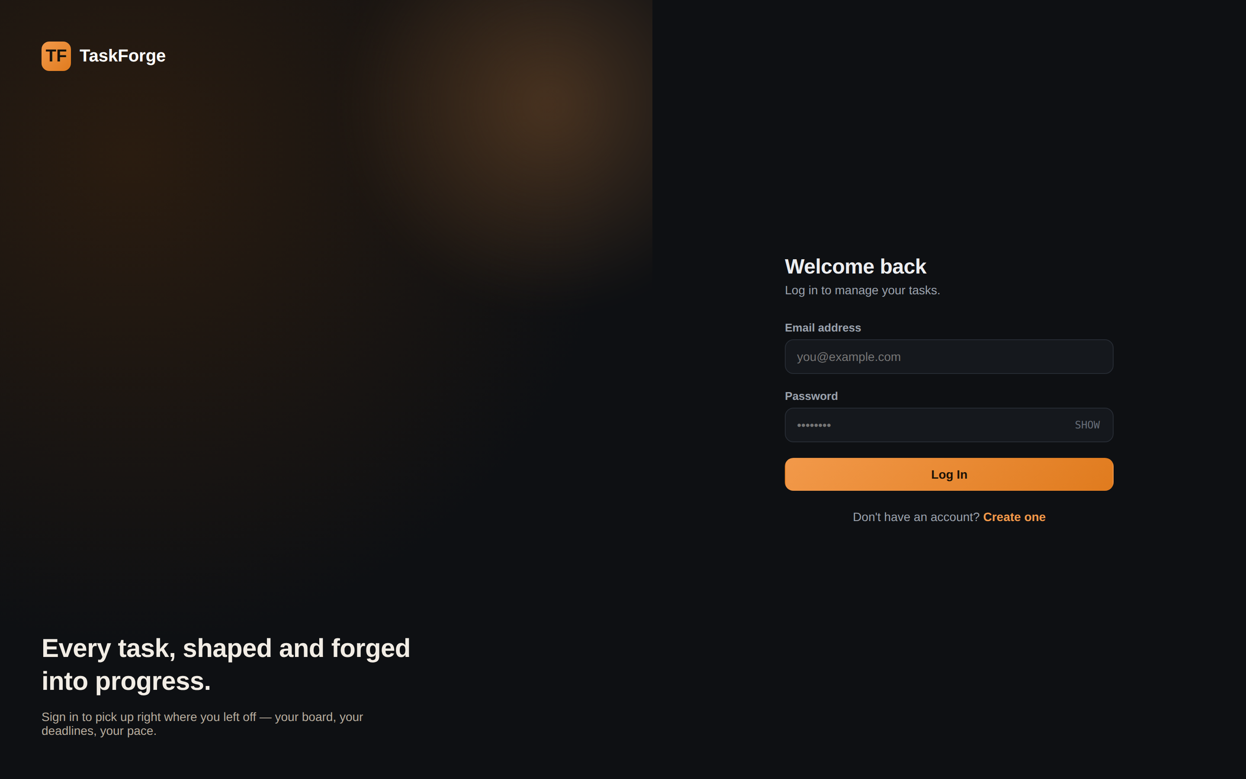
Figure 1 — Login page

5.2 Dashboard
The authenticated home screen: stat cards (Total, In Progress, Completed, Overdue), status/priority breakdown charts, and a searchable, filterable, paginated task table.
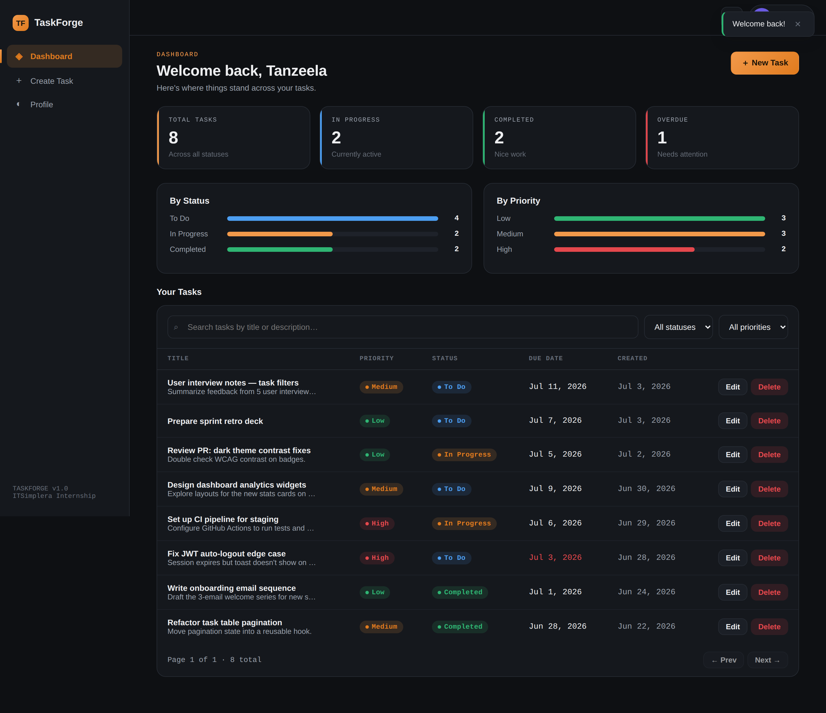
Figure 2 — Dashboard, dark theme
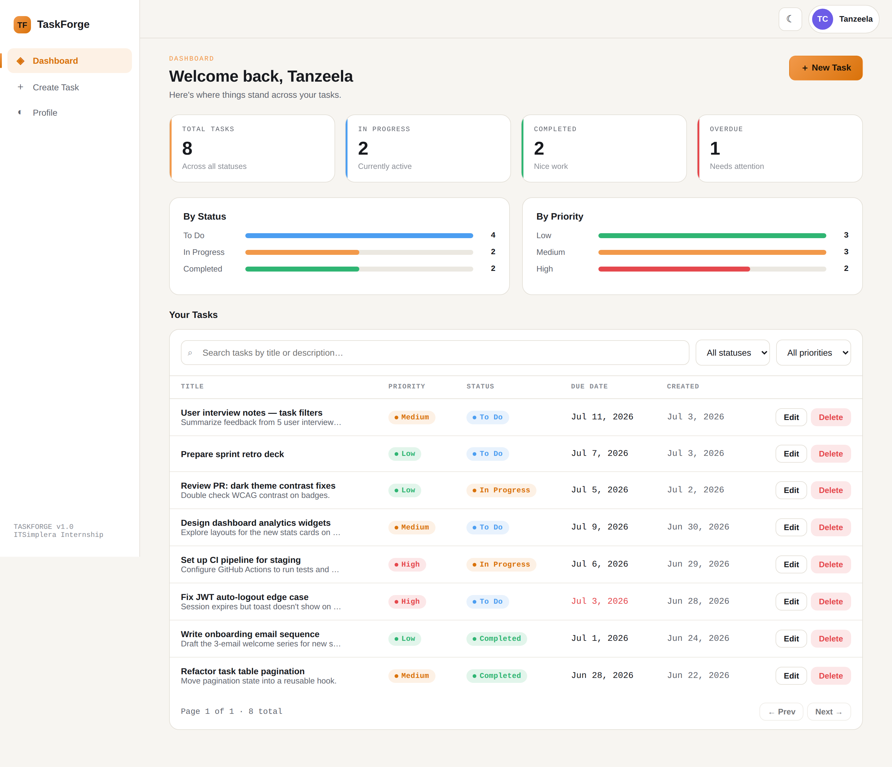
Figure 3 — Dashboard, light theme

5.3 Create & Edit Task
Both forms share one component, with client-side validation for title and due date.
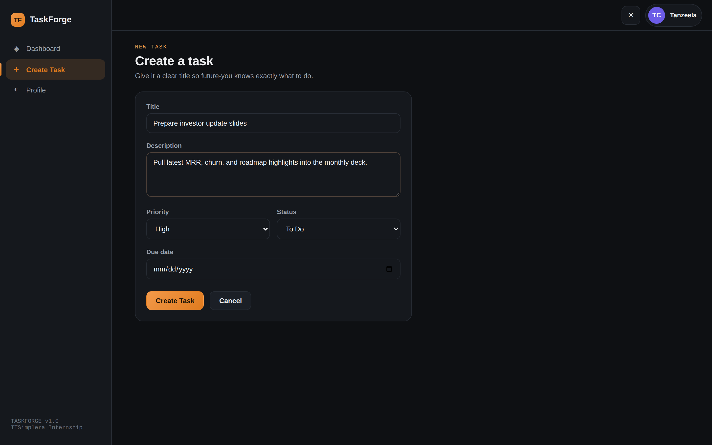
Figure 4 — Create Task form

5.4 Profile & Password Change
Users can update their name/bio and change their password after re-entering the current one.
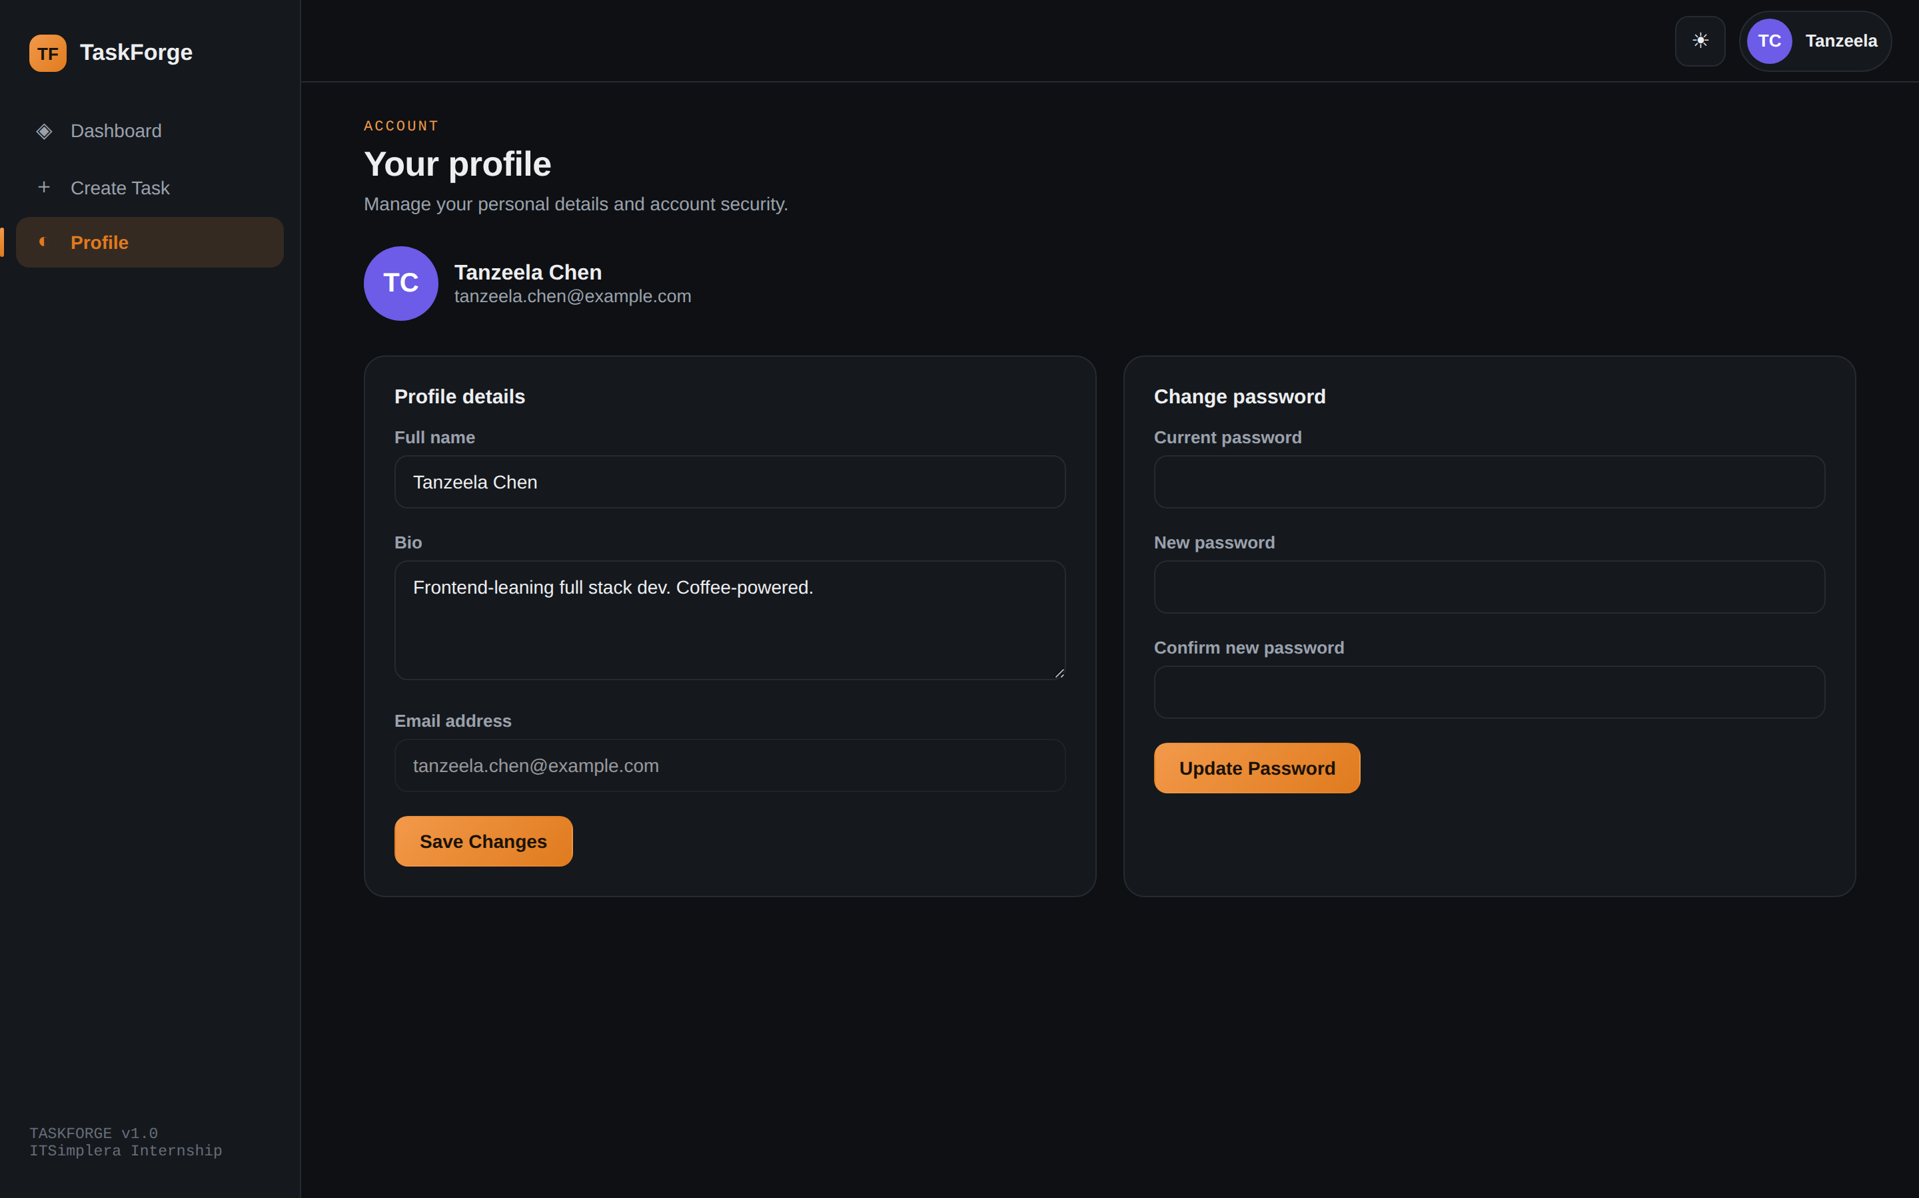
Figure 5 — Profile page

5.5 Delete Confirmation & Mobile View
Deleting a task requires modal confirmation. Below tablet width, the sidebar collapses behind a hamburger menu.
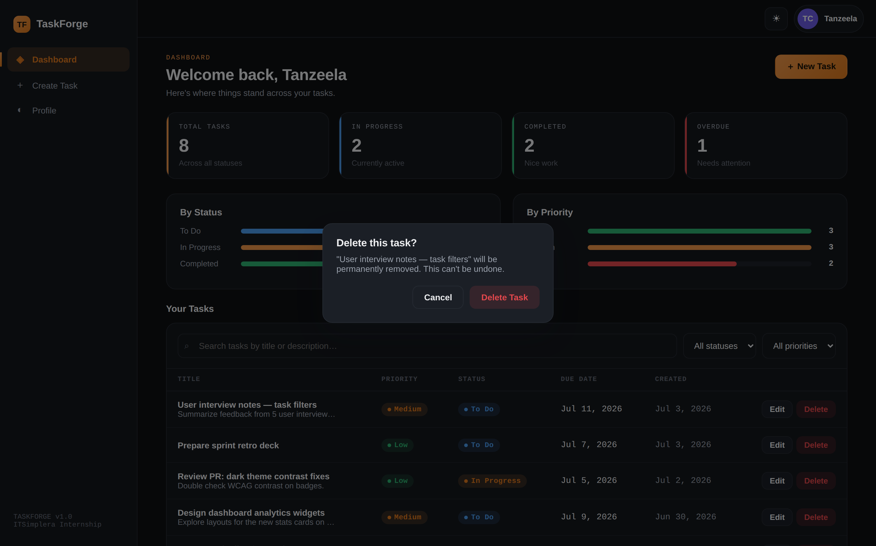
Figure 6 — Confirm-delete modal
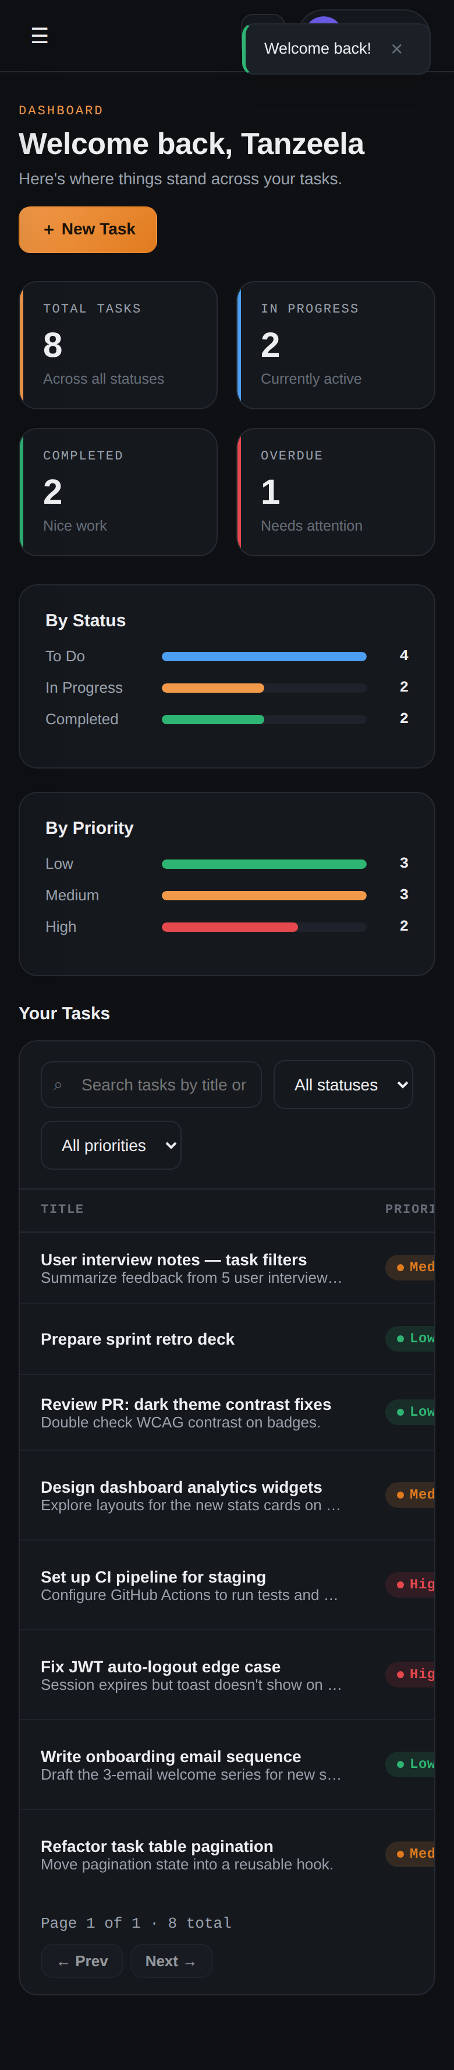
Figure 7 — Mobile dashboard (390px)

6. REST API Reference
All protected endpoints require an Authorization: Bearer <token> header.
Method | Endpoint | Description | Protected
POST | /api/auth/register | Register a new user | No
POST | /api/auth/login | Authenticate, receive a JWT | No
GET/PUT | /api/users/me | Get / update profile | Yes
PUT | /api/users/change-password | Change password | Yes
GET | /api/tasks | List (search, filter, paginate) | Yes
GET | /api/tasks/stats | Dashboard statistics | Yes
POST/PUT/DELETE | /api/tasks/:id | Create / update / delete | Yes

7. Security & Data Model
- Passwords hashed with bcrypt; plaintext is never stored.
- JWTs are signed and expiring; expired/invalid tokens return 401.
- All task queries are scoped to the logged-in user's ID.
- Request validation via express-validator; centralized error handling.

8. Additional Features Implemented
Eight bonus features (five required): search, status filter, priority filter, pagination, profile update, password change, dashboard statistics, and auto-logout on JWT expiry.

